**SQL ASIGNMENT-1**

**QUESTIONS:**

**Part-1:**

Write a query to insert a new employee into the Employees table with values (1, 'John', 'HR', 50000).

Write a query to insert multiple rows into a table in a single query.

Write an INSERT query where only some columns are provided (not all).

Write a query to update the salary of an employee with ID = 101 to 60000.

Update the department of all employees from 'Sales' to 'Marketing'.

Increase salary by 10% for all employees in the 'IT' department.

Write a query to update multiple columns in a table using a single statement.

Write a query to delete a record from the Employees table where ID = 5.

Delete all employees whose department is 'HR'.

Delete all records from a table but keep the structure.

Write a query to add a new column DOB of type DATE to the Employees table.

Modify the data type of the column Salary from INT to FLOAT

**Part-2:**

Write a query to create a table called Students with columns: ID, Name, Age, and Email.

Create a table and set the default value of the status column to 'Active'.

Write a query to drop a table named TempData.

Write a query to drop a column from an existing table.

Add a NOT NULL constraint to the email column in the Users table

**Part-3:**

Create a table Orders with a foreign key referencing the Customers table.

Create a table with a primary key on multiple columns.

Drop only the primary key constraint from a table.

**ANSWERS:**

**Part-1:**

create database Com;

use Com;

create table Employees(Id int,EmployeesName varchar(100),Department varchar(100),Salary int);

insert into Employees values(1,"John","HR",50000);

insert into Employees

values(2,"Abilash","Marketing",40000),(3,"Santhosh","R&D",60000),(4,"Kailash","Manufacturing",60000);

insert into Employees values(101,"Shiva","IT",50000),(102,"Shyam","IT",60000),(112,"Krish","Sales",60000),(111,"Ram","Sales",40000),(103,"Riyas","IT",70000);

insert into Employees values(5,"Janani","HR",50000);

insert into Employees (Id, EmployeesName, Salary)

values (15, 'Jay', 50000);

select*from Employees;

update Employees set ID=101 where Salary=60000;

update Employees set Department="Marketing" where Department="Sales";

update Employees set Salary = Salary * 1.10 where Department = 'IT';

update Employees set Department = 'HR', Salary = 55000 where Id = 15;

delete from Employees where Id = 5;

delete from Employees where Department = "HR";

truncate table Employees;

alter table Employees add DOB Date;

alter table Employees modify column Salary float;

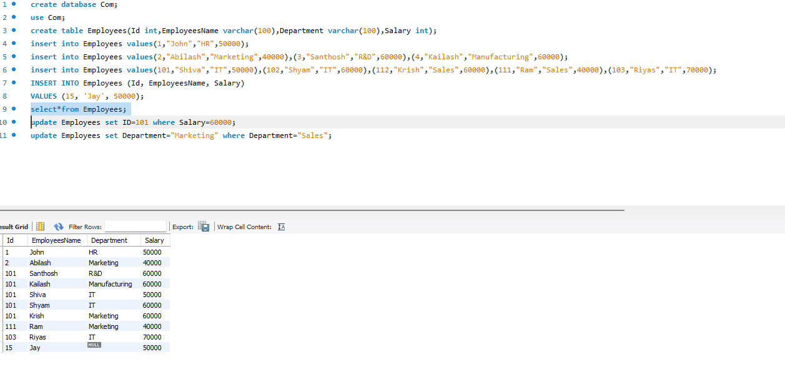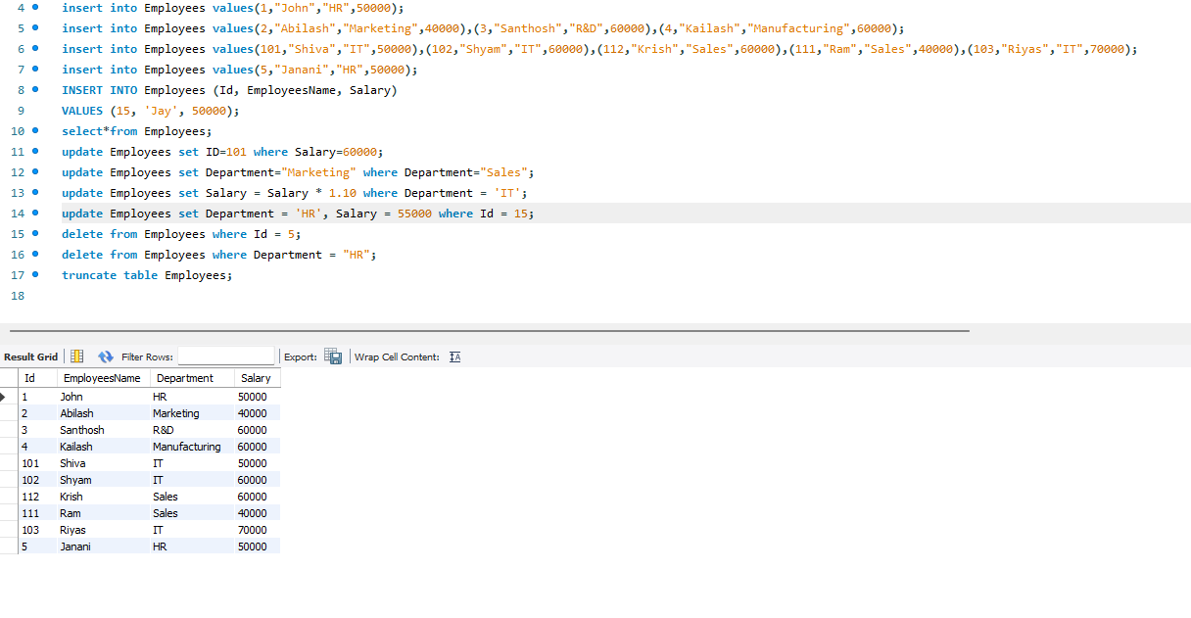

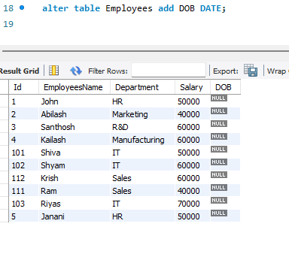

**Part-2:**

create database stu;

use stu;

create table Students (ID int,Name varchar(100),Age int,Email varchar(100));

select*from Students;

create table Accounts (AccountID int,UserName varchar(100),Status varchar(20) DEFAULT 'Active');

select*from Accounts;

insert into Accounts (AccountID, UserName)values(1, 'Santhosh');

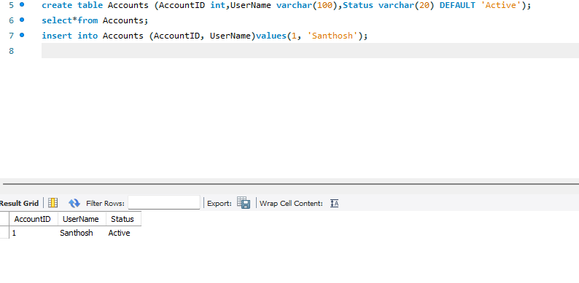

create table TempData (AccountID int,UserName varchar(100),Status varchar(20) DEFAULT 'Active');

select*from TempData;

insert into TempData (AccountID, UserName)values(1, 'Santhosh');

Drop table TempData;

alter table Students Drop column Age;

alter table Students modify column Email varchar(100)not null;

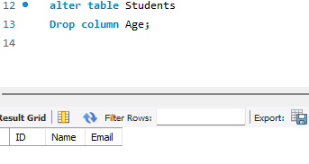

**Part-3:**

use new;

create table Customers (CustomerID int primary key,CustomerName varchar(100),ContactNumber varchar(15));

create table Orders (OrderID int primary key,OrderDate date,CustomerID int,Amount decimal(10, 2),foreign key (CustomerID) references Customers(CustomerID));

insert into Customers (CustomerID, CustomerName, ContactNumber)values(1, 'John Doe', '9876543210');

insert into Orders (OrderID, OrderDate, CustomerID, Amount)values(101, '2025-08-07', 1, 1500.00);

select* from Orders;

select* from Customers;

create table OrderDetails (OrderID int,ProductID int,Quantity int,Price decimal(10, 2),primary key (OrderID, ProductID));

insert into OrderDetails (OrderID, ProductID, Quantity, Price)values(1, 101, 2, 499.99);

insert into OrderDetails (OrderID, ProductID, Quantity, Price)values(1, 102, 1, 699.99);

select*from OrderDetails;

insert into OrderDetails (OrderID, ProductID, Quantity, Price)values(1, 101, 5, 599.99);

alter table OrderDetails drop primary key;

rename table Customers to Clients;

select * from Clients;

